Michael Friedmann
Dr. Griswold
SPED 860
Module 7 Assignment
April 30, 2023

SELF-MANAGEMENT STRATEGIES/SYSTEM FOR BOBBY GIBSON

STUDENT INTRODUCTION: BOBBY GIBSON
[Student information based upon psychological evaluation conducted by Dr. Leo Kanner]

Bobby Gibson is a middle school student (ages 12 to 14) at Jay Hawk Middle School who is “currently eligible for special education services in the disability area of Autism with a secondary eligibility area of Seriously Emotionally Disabled.” Furthermore, “Bobby has a history of serious behavior problems, absences and hospitalizations [and] has received special education services since he was four-years old.” Self-management strategies for Bobby will focus specifically on behavioral interventions and modifications to help Bobby recognize and understand how to, and when to self-regulate and apply his self-management strategies and routines, specifically when in general education classroom settings for math and science (where data from his FBA indicates that Bobby experiences the greatest number of behavioral challenges).

DIAGNOSIS:

Bobby has been “diagnosed with attention-deficit/hyperactivity disorder (AD/HD), autism spectrum disorder (ASD), and oppositional defiant disorder (ODD).” Bobby presents with HFA (high-functioning autism).

STUDENT’S PERSONAL INTERESTS AND STRENGTHS:
[Student information based upon student interview]

Bobby has exhibited an interest in “girls” and has stated that he “likes girls” but that he does not “have a girlfriend” and that he wishes that he “did.” Bobby has further articulated the fact that he “loves” an “all-girl band” called the “Tune-yards” and that his father “hates” them. Their song is his current ringtone on his phone. Bobby is a self-proclaimed “serious gamer” and has stated that “if [he] was allowed to, [he] would play video games all day, every day.” Bobby has stated that his “favorite game that can be accessed on a mobile platform is Immortalis (a digital card game).” Bobby has further confessed to the fact that, while he recognizes that he is “not supposed to play” the game “at school” he “hides [his] phone in [his] desk in math class and plays it when [he] does not understand what is going on.”
Bobby has shared his interest in the movie “8-Mile” which he watched on Netflix, which prompted his desire to purchase the soundtrack which contains songs by the rap artist “Eminem.” Bobby has further stated that he enjoys “hip-hop” and that he uses “hip-hop” music for his own posts on an app called “musical.ly” yet further conveyed the fact that while he finds the app “hilarious” he seems disappointed that “no one ever likes [his] stuff” (referencing his posts). Bobby also articulates that “[his] world is intense” and that his mother would agree. Bobby further articulated the fact that “when [he] gets super stressed, which happens a lot after school” that those are the most “intense” moments for him. Bobby seems to focus on these “intense” moments as pivotal times in his day, he retains the emotions of those “intense” experiences/moments. Bobby also conveyed the fact that “[he] hates taking meds…[because] they make him feel weird.” According to Bobby, his mother “thinks they help [him].”
Bobby enjoys having “time by himself” and he conveyed the fact that “some people think it’s weird when I go off by myself to think about video games or politics.” In contrast to this, Bobby feels that “it’s weird that other kids always want to be with other people.” This perception of social norms expressed by Bobby is further supported by how he feels when people get physically close to him, and he explains that “[he] really [doesn’t] like when people get really close and bump into [him]” which is part of why Bobby struggles in the school lunch room setting, which he states is “really annoying because people move all over and act crazy.”

STUDENT’S ACADEMIC STRENGTHS AND NEEDS:
[Student information based upon IEP and BIP content and student’s Autism worksheet/assessment]

Bobby’s Autism Worksheet, Behavioral Intervention Plan, and Individualized Education Program all indicate that “Bobby’s areas of relative strengths include his cognitive (thinking/learning abilities), and his sincere desire to learn and respond well to positive reinforcement.” Furthermore, “additional areas of strength include his academic skills in word recognition/phonetic usage and mathematical problem solving.” It is consistently notated that “Bobby is able to use receptive and expressive language skills when motivated to communicate effectively with others in a limited manner” and “Bobby has average handwriting abilities, and he can use a computer to communicate his thinking effectively.”
Bobby’s Autism Worksheet, Behavioral Intervention Plan, and Individualized Education Program all indicate that Bobby’s overall strengths include his normal abilities in “acquisition of information, reasoning, and expression.” Furthermore, “Bobby’s verbal ability to interpret and respond to orally presented tasks falls [within] the average range.” Bobby can also “easily identify similarities between objects and use verbal clues to identify objects” and “Bobby demonstrates normal nonverbal abilities.” Bobby’s “ability to interpret and organize visual material falls in the High Average range” and “Bobby’s relevant academic strengths are his ability to understand what he has read about a given topic of interest, his artistic ability, creative ideas and ability to use the computer for multiple assignments.” Additionally, “Bobby has a satisfactory range of whole-word recognition, and his reading decoding abilities are in the average range.”
Bobby does struggle with “answering literal and inferential comprehension questions, as well as sequencing events from passages he reads” yet “Bobby has good basic reading skills and fluency.” Bobby does present with a “difficulty with comprehension tasks” yet “Bobby is able to write on topics of interest, and when given an organized writing assignment, he can include an introductory statement and a supportive argument.” Bobby “needs to [word towards] includ[ing] a concluding statement, elaborate on his written argument, and develop[ing] supportive arguments.”
With mathematical computation, “Bobby can compute multi-digit number sentences using the four arithmetic operations” but “he is inconsistent [with his] multiplication and division facts” which indicates that “he is stronger at problem solving tasks than calculation skills.”
“The results of these assessments indicate several academic and social/behavioral skill deficits” including challenges with “reading comprehension of abstract ideas and considering different perspectives.” Additionally, “Bobby has difficulty adequately explaining his ideas in sufficient details for readers to understand his own perspective.” As noted previously, “math calculations and word problems are an area of weakness” for Bobby. Furthermore, Bobby struggles with “his social and emotional needs…with overreacting to social situations and physical touch, problem solving, seeing the “bigger picture” when frustrated, adaptive behavior and social boundaries.”

ACADEMIC SETTING AND STRUCTURED TEACHING PROGRAM:

Bobby began this school year at Jay Hawk Middle School. Due to a behavioral incident early in the school year, Bobby was suspended and was required to enroll in an alternative hospital setting for six months. Currently Bobby’s report cards show mostly Cs and Ds. However, he has earned mostly Bs on grade reports from last year. Bobby has a history of medically and behaviorally related school absences. At present, the number of absences has significantly increased. In a brief interview, Bobby indicated that he lives with his mother and father. He contended that he needs special education because there are fewer students in special education. Bobby considers social studies his best subject and math his toughest. He shared that he enjoys art and cooking. Bobby reports that he takes medicine for attention and behavior. Bobby’s current academic setting is problematic due to him struggling with the subjects of math and science, due to the general education classroom environment, and possibly directly related to teaching style of both subjects and a lack of visual supports and interventions and a learning environment not conducive to someone with ASD who requires additional supports for math and science to be successful, which has resulted in the behaviors indicated as challenging in his FBA. The teaching style, noise-level, presence of too many other students, the seating arrangement, the classroom management style, content and subject matter, along with a lack of visual supports may all be reasons for Bobby struggling in both subjects of math and science.
Previously, a Structured Teaching Program was developed for Bobby in order to address some of Bobby’s deficits and hurdles managing a classroom environment, specifically during math and science, where Bobby’s grades indicate he is struggling the most academically, and where Bobby’s FBA indicates that he is manifesting the greatest number (or interval) of behaviors. As the end-goal for Bobby would be to work towards being able to manage a classroom environment without manifesting behaviors and without elopement, all while achieving additional goals of assignment completion, and remaining in his seat, and not talking out of turn or being disruptive, the implementation of Bobby’s “Structured Teaching Program” was meant to facilitate Bobby’s success in both math and science, by removing him from those classroom environments, and placing him in an environment that was more conducive to his learning style. Bobby’s “Structured Teaching Program” incorporated the following plan:
“Removing Bobby from a general education classroom environment, into a Resource Support environment where he has the ability to either 1) work independently in a quieter setting, or 2) work one-on-one with an educator, or 3) have work expectations clearly outlined and defined and even broken down into smaller segments and 4) have access to visual supports, will definitively provide Bobby with a way of learning the curriculum in an environment with fewer distractions and allow Bobby to raise his grades for math and science.”
Upon further review of this “Structured Teaching Program” and in consideration of the behavioral supports needed for Bobby to adapt self-management strategies to help him cope and manage his behavioral manifestations which all (based upon his FBA) tend to be directly indicative of task avoidance. Bobby’s FBA indicates that: “the Hypothesis’d function of the behavior is “Escape from task demands.” Adapting Bobby’s current “Structured Teaching Program” to accommodating Bobby’s need for “Self-Management Strategies” appears to be the most reasonable and applicable solution to address both deficits and compartmentalize them into one plan that Bobby can initiate on his own when he recognizes the need for those “Self-Management Strategies.” By providing Bobby with a place where he can go and complete his math and science with the supports, he may need to do so, Bobby has a way to be successful with his academics. By NOT making Bobby’s Resource Support location a mandatory daily location where Bobby has to go to complete his math and science curriculum, but rather, creating that very same “Structured Teaching Program” in a manner that would incorporate Bobby’s “Self-Management Strategies” it would allow Bobby to be the purveyor of his own fate, and be self-determined (which is the goal of all of this) in when and how he chooses to utilize the Resource Support location for his academics. Bobby should be able to have visuals in place in his math and science classroom, which will allow him to communicate to his teachers, without the use of verbal communication, such as a red card and a green card, that Bobby can independently access and display on his desk, to communicate to his teacher that he needs to relocate to the Resource Support Center for independent work, or for support with his work, if he is struggling. Allowing Bobby to make this determination of need based upon environment and content, is a socially valid skill that Bobby will be able to apply in all aspects of his life, as he evolves his ability to self-manage emotions, and tasks and obstacles and meet end-goals with success.
Based upon all interviews, and assessments and evaluations reviewed, Bobby is fully capable of self-management and self-determination, providing he has the ability to communicate the need to relocate to another location that may be quieter or provide a better learning environment conducive to his learning method and style.
Any challenges to these protocols are minimal, as there are very few working parts, and Bobby
already has a “Structured Teaching Program” in place, which he has utilized with great success.

STRUCTURED TEACHING PROGRAM MODIFIED INTO A SELF-MANAGEMENT STRATEGY FOR BOBBY:
[Educational Plan/Program: General Education with Resource Supports as a Self-Management Strategy]

Bobby’s current academic/educational setting is middle school. Bobby does attend general education classes which provide an inclusive and dynamic social environment which provides Bobby with an academic setting with others, where he can learn with other students, while also providing Bobby with an environment prone to potential behavioral disruptions due to stimuli or triggers which can push Bobby into distractions or escalations based on any number of variables, from students touching him, or Bobby not staying in his own area, or using his phone when not permitted, or struggling to follow the instruction or complete assignments.
Of all the subjects that Bobby attends, math and science seem to be the most difficult for him to manage and focus on to a successful level, and his academic needs (based upon his grades, and his inability to complete math and science work) would indicate that placing Bobby in a more supportive (and least restrictive) resource environment for math and science, where more visual supports may be utilized, may be the most beneficial option to help him focus and aid in his ability to complete the required work with the help of an educator in order to raise his grade and his understanding of the subject matter.
Given Bobby’s diagnosis, the use of visual interventions for math and science instruction may be beneficial and aid Bobby in learning math and science in a manner that the standard classroom setting is not able to provide. “Many individuals with autism spectrum disorders (ASDs) are referred to as visual learners” (Earles, Carlson, & Bock, 1998; Earles-Vollrath, Cook, & Ganz, 2006). Furthermore, “visually based interventions are recommended for individuals with ASD because it is thought that visual processing is a relative strength for many of these individuals” (Schopler, Mesibov, & Hearsey, 1995) and “visuals decrease students' reliance on areas of deficit, including auditory processing, memory, and communication.” Lastly, “visual strategies are thought to increase student independence and decrease dependence on adult prompts, cues, and correction.” Integration of visually based interventions in support of Bobby’s math and science coursework may benefit Bobby and aid him in how he learns a subject matter in which he is currently struggling. Allowing Bobby to be self-determinant in how and when he utilizes the services of the Resource Support Center, while relying heavily on Bobby’s ability to interpret when he may need such supports, is a functional opportunity for Bobby to learn a fundamental and practical life skill of self-management, such as asking for help, communicating when that specific help is needed, and then going to the location where he understands help will be available.

SELF-MANAGEMENT STRATEGIES FROM A STRUCTURED TEACHING PROGRAM TO ACCOMMODATE NEEDS:

“Self-management systematizes self-regulation strategies for learners with ASD in order for
learners with ASD to learn the rules and norms needed to act appropriately in a given situation [and] self-regulation strategies can include self-monitoring, self-reflection, and adapting to a given context [and, furthermore] self-management is both a tool to teach other skills/behaviors and an important skill in itself” (Sam & AFIRM; 2016, p. 2). Bobby’s current academic environment for math and science are not meeting Bobby’s academic needs nor are they providing Bobby with a learning environment conducive to his success in the subject area of math and science, and modification of that environment, to one with less distraction and disruption would help Bobby to be more successful in his learning process by utilizing visually based interventions in that new environment, reducing Bobby’s negative behaviors. Furthermore, allowing Bobby to be self-determinant in how and when he self-manages his need for resource supports, when he requests them, and when he utilizes them, will create the very outcome for Bobby’s goals that we are seeking with implementing FBA’s, and IEP’s and BIP’s, and striving towards with IEP goal setting, and creating “Structured Teaching Programs.” By incorporating reinforcers, such as a “star chart” where he can earn signatures from his teachers for following expectations and completing assignments and appropriate communication, Bobby can earn time doing preferred activities, such as playing piano, or playing games on his laptop. Bobby’s self-management strategy should incorporate reinforcers that evaluate not only his daily responses to expectations, but also provides larger and more desirable monthly reinforcers if he has been compliant for longer periods of time. With Bobby’s HFA, it should be feasible to motivate him towards a larger reinforcer at the end of a 30-day window, prompting more self-management and completion of work and behaviors, as well as less defiance and elopement activity and task avoidance.
The development of this modification of a “Structured Teaching Program” to a “Self-Management Strategy” is supported by observations and evidence from Bobby’s BIP and IEP and FBA, which indicate that “Bobby has difficulty remaining on task for and keep pace with instructional demands in the general education classroom if he is not interested or motivated to be successful with the task at hand” and “when this happens, Bobby typically engages in task avoidance behaviors to escape the undesired settings and/or tasks which minimize his time in class and inhibit him from making satisfactory educational progress.” Additionally, “Bobby has difficulty with problem solving” especially when he is “frustrated” and Bobby “has difficulty establishing and maintaining appropriate social relationships with the adults and peers in the educational and community settings” which prompt the transition to a modified environment where Bobby can work quietly, without the presence of peers, with visual supports, and with an educator in a 1:1 setting. Additionally, Bobby’s FBA incorporates the “use visual supports within the classroom (red card/green card) that signal when he can talk and when he cannot talk [and] the last 5 minutes of class will be given to Bobby to freely socialize with those around him while everyone is waiting on the bell to ring.” Small interventions and reinforcers such as these will aid in helping Bobby to self-manage his behaviors.
Furthermore, “the evidence from Bobby’s psychological assessments, observations in educational settings, school academic records and behavioral data sheets indicate that Bobby needs specially designed instruction from a special educator to support functional/academic and social skills in the classroom in order to progress in the general curriculum.” This must be directly applied to how Bobby learns and engages with his math and science curriculum in order to assure a successful environment conducive to the variations in which Bobby learns and which allow Bobby the ability to engage with the material in a manner which will allow him to understand the curriculum by utilizing visual interventions and a less-distracting environment. Implementing such interventions and supports should further be incorporated into a self-managing strategy for Bobby, to aid him in recognizing when and how he needs access to such supports, with a goal of self-determination as well as success in navigating the correction of, and the self-management of disruptive or unwanted behaviors.

OPERATIONAL DEFINITION OF A SELF-MANAGING SKILL:
While in the classroom, specifically math or science, Bobby will communicate his need for a modified/alternate learning environment, using self-management skills, by using his red or green card to indicate he will go to the Resource Support Center to complete his assignment. Bobby will also utilize a behavior chart with his teachers in order to earn desired reinforcers for compliance and meeting expectations.
- Target behavior: Bobby engages in task avoidance and elopement behaviors by leaving his seat or leaving the classroom and/or disruption such as talking and walking around the classroom when he finds math or science difficult to manage or confusing.
- Replacement behavior: Bobby will use his red or green card to communicate his need for a modified/alternate learning environment.
- Operational definition of the replacement behavior: Bobby will use self-management strategies to communicate his need for a modified/alternate learning environment and be given permission to leave the classroom and go to the Resource Support Center.

IMPLEMENT AND MONITOR PROGRESS AND DATA COLLECTION TOOLS:

As Bobby has already transitioned into a new academic quarter, and there are only six-weeks of school left in the academic year, implementation of this self-management strategy will be made immediately, with daily progress monitoring to determine its success and/or failure, and if modifications or clarifications are needed. Expectations for behaviors will be clearly laid out with Bobby by RSC staff, by providing him a behavior chart and a clear explanation of what the new plan will be for him. As with Bobby’s “Structured Teaching Program” maintaining normality, as much as possible, is a fundamental part of measuring success in implementing this plan, as well as monitoring Bobby’s progress. As other students have benefitted from such structured teaching programs, Bobby will acclimate to the environment and learning interventions quite well, given his needs and what the new learning environment can and will provide him.
Further implementing the self-determinant element to this self-management strategy will allow Bobby to be the “narrator of his own story” and learn to recognize when and how he will need to request Resource Support. Assessing the effectiveness of this structured teaching program will be done by monitoring the daily completion of Bobby’s behavior chart, assessing daily data collection on intervals, and evaluating the assignments completed by Bobby. The initial criterion for this target behavior will be reliant upon Bobby determining when and how he requires interventions, and observational data on when Bobby utilizes his card system to request Resource Support, resulting in Bobby obtaining compliance marks on his behavior chart in order to obtain his desired reinforcers.
Bobby’s behavior chart will have a two-part system by which not only his teacher’s will place marks upon it, but Bobby will also evaluate his own successes in embracing and applying his self-management strategies on a daily basis. Bobby will spend an afternoon with the Resource Support Center staff to learn the new self-management strategy system, and RSC staff will encourage Bobby to participate in critiquing and evaluating his own “buy-in” into the new system. This will allow the RSC staff to modify anything that may seem difficult to manage or introduce Bobby’s suggestions if they fit into the strategy. Bobby will be taught the system, in hopes that he will be motivated to work with it and use it to further his own successes in self-management.
Bobby will gain access to reinforcements at the end of the day, when he checks in with RSC staff who will evaluate his behavior chart and discuss with him any issues he may have had throughout the day, while praising his successes and granting him access to the piano or a laptop for free time (his reinforcers). Administration will need to be involved in any larger reinforcer that Bobby may earn for 30-days of compliance and completion of his behavior chart. The idea of “Principal for a Day” may be a very interesting method of introducing something more social to Bobby while also imparting some responsibilities for a day and also giving him a sense of purpose and being in the school.

CHARTS, DATA TRACKING & CHECKLISTS:
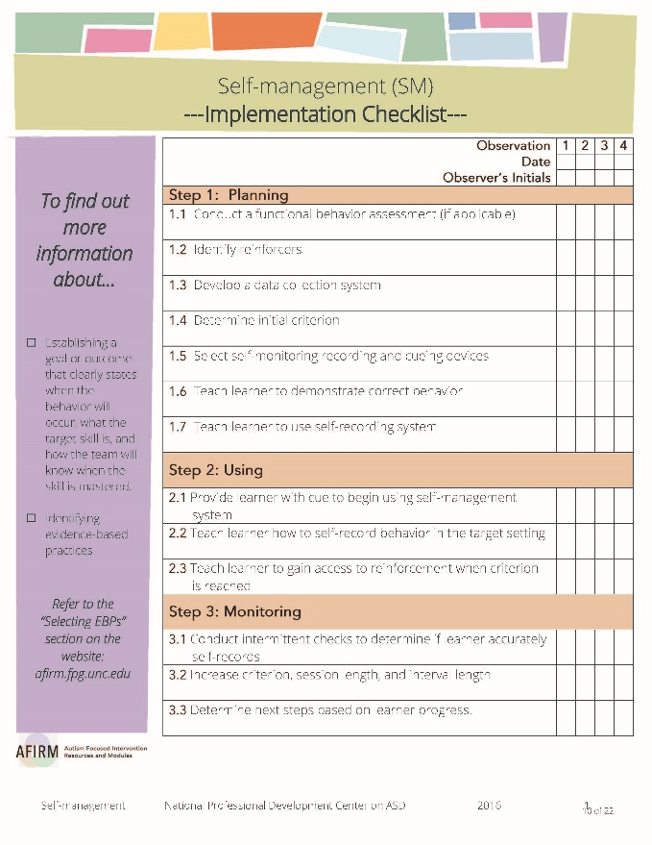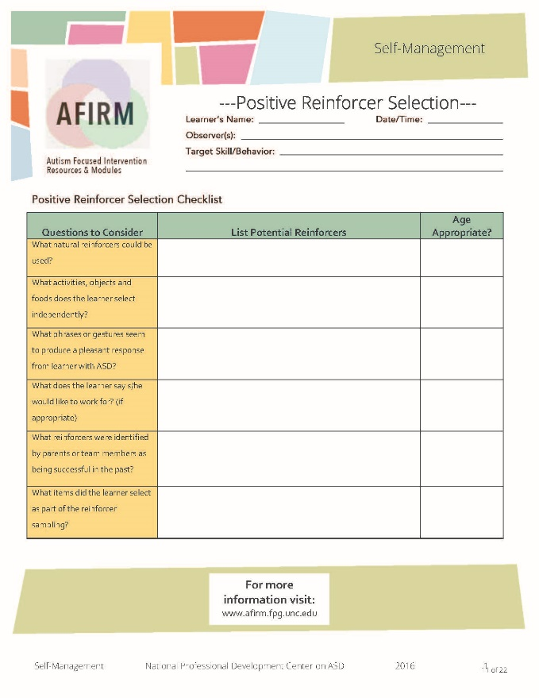
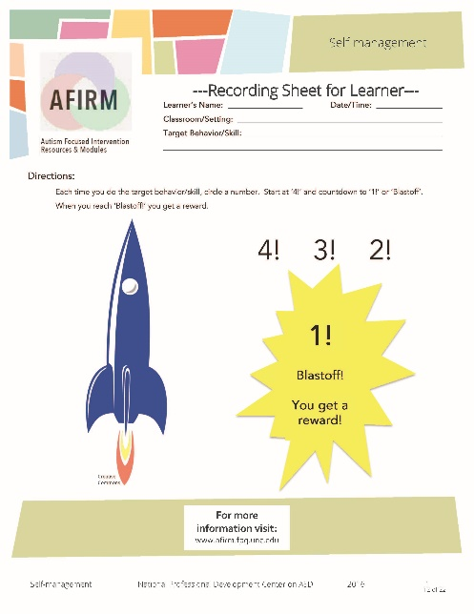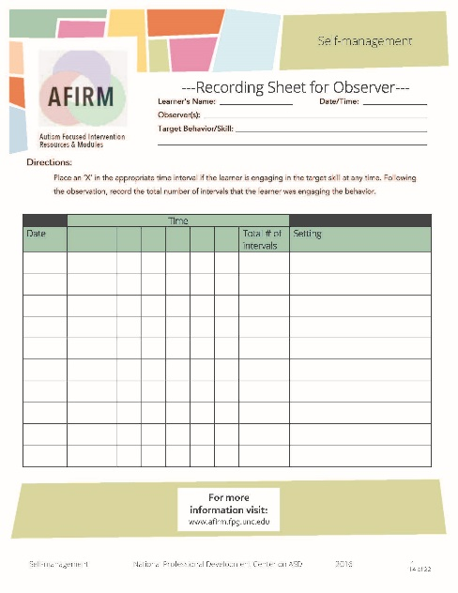
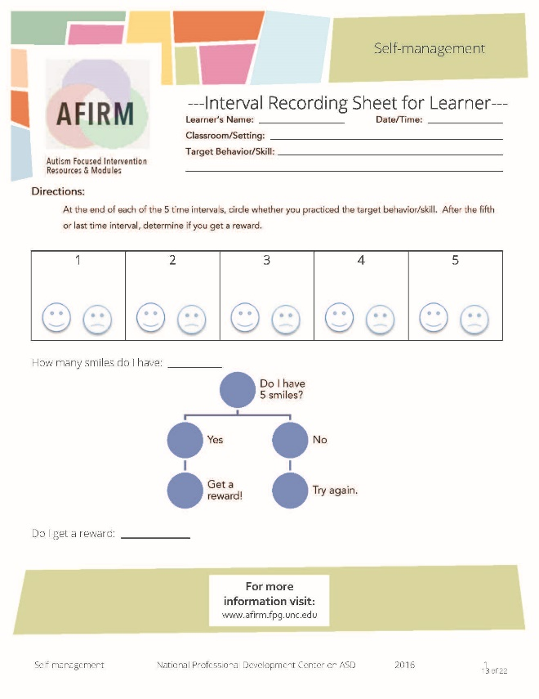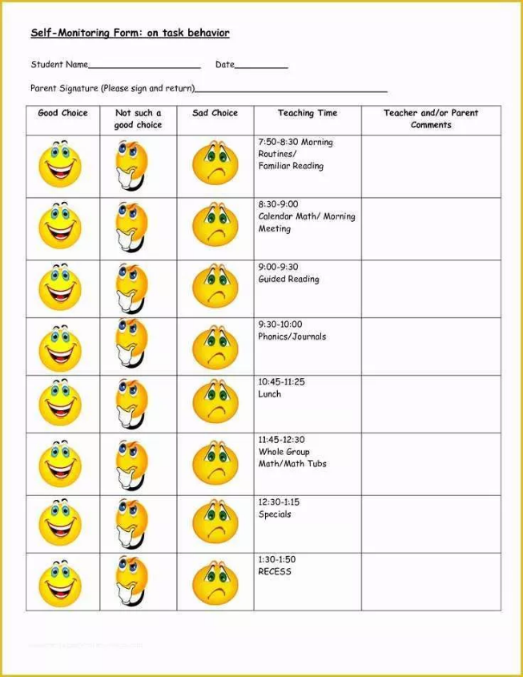
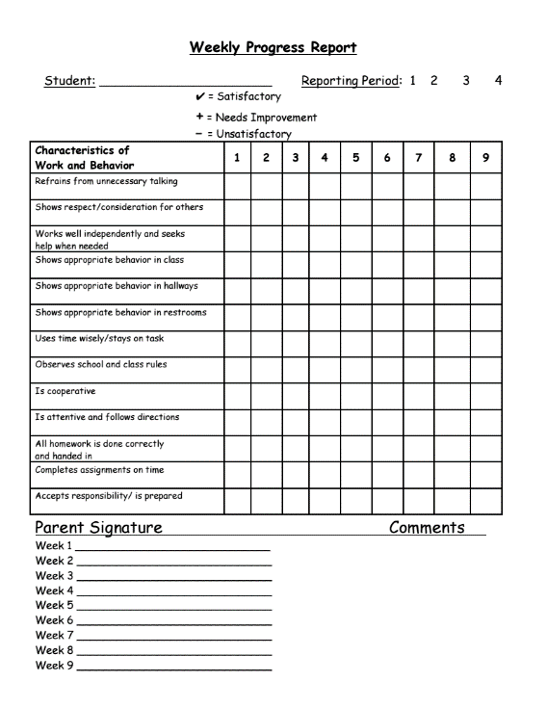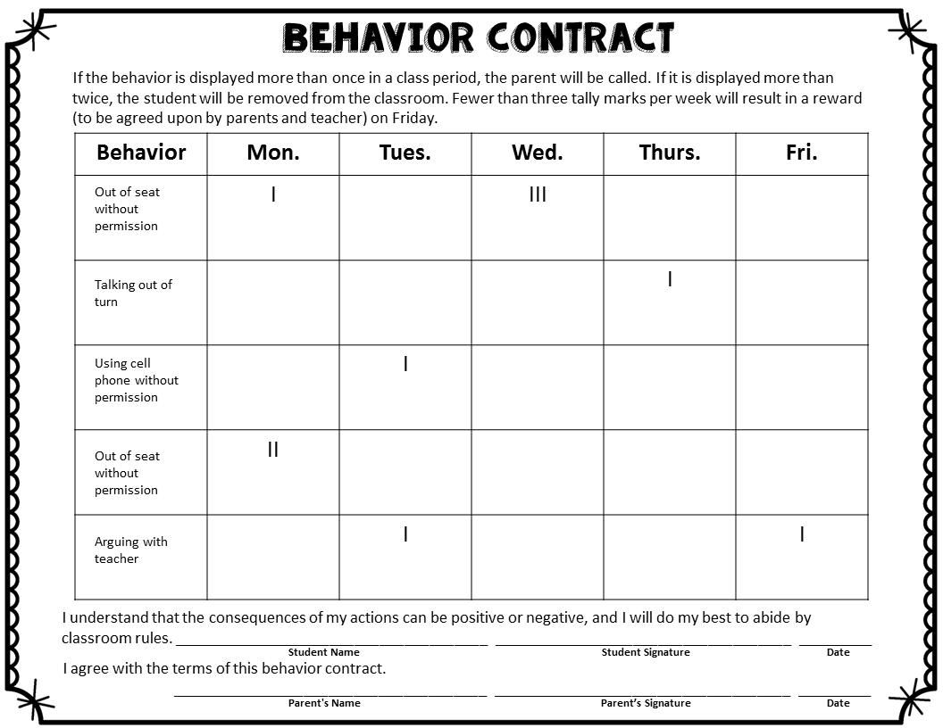

REFERENCES:

Ciccarelli, S. K., & White, J. N. (2014). Psychology: Dsm 5. Pearson.
Delia, L., Valeri, G., Sonnino, F., Fontana, I., Mammone, A., & Vicari, S. (2014). A longitudinal study of the TEACCH program in different settings: The potential benefits of low intensity intervention in preschool children with autism spectrum disorder. Journal of Autism and Developmental Disorders, 44(3), 615-626.
Earles, T. L., Carlson, J. K. and Bock, S. J. 1998. “Instructional strategies to facilitates successful learning outcomesfor students with autism”. In Educating children and youth with autism: Strategies for effective practice, Edited by: Simpson, R. L. and Myles, B. S. Austin, TX: Pro-Ed.
Earles-Vollrath, T. L., Cook, K. T. and Ganz, J. B. 2006. How to develop and implement visual supports, Austin, TX: Pro-Ed.
Foxx, R. M. (2016). Chapter 14: Perpetuation of the myth of nonaversive treatment of severe behavior. In R. M. Foxx & J. A. Mulick (Eds.), Controversial therapies for autism and intellectual disabilities: Fad, fashion, and science in professional practice (2nd ed.). (pp. 223-244). Routledge. 978- 1138802230.
Ganz, J. B. (2007). Classroom structuring methods and strategies for children and youth with autism spectrum disorders. Exceptionality, 15(4), 249–260. doi:10.1080/09362830701655816.
Individuals With Disabilities Education Act, 20 U.S.C. § 1400 (2004). (n.d.).
Pennington, R.C. (2019). Chapter 8: Schedules of reinforcement & extinction. In R. C. Pennington (Ed.), Applied behavior analysis for everyone: Principles and practices explained by applied researchers who use them. (pp. 108-122). AAPC Publishing.
Sam, A., & AFIRM Team. (2016). Self-management. Chapel Hill, NC: National
Professional Development Center on Autism Spectrum Disorder, FPG
Child Development Center, University of North Carolina. Retrieved from http://afirm.fpg.unc.edu/Self-management.
Sam, A., Savage, M., Steinbrenner, J., Morgan, W., Chin, J., & AFIRM for Paras Team. (2020). Reinforcement: Introduction and practice. National Professional Development Center on Autism Spectrum Disorder, FPG Child Development Center, University of North Carolina. Retrieved from http://afirm.fpg.unc.edu.
Schopler, E., Mesibov, G. B. and Hearsey, K. 1995. “Structured teaching in the TEACCH system”. In Learning and cognition in autism, Edited by: Schopler, E. and Mesibov, G. B. 243–267. New York: Plenum.
Scheuermann, B. and Webber, J. 2002. Autism: Teaching does make a difference, Belmont, CA: Wadsworth Group.
Szakacs, W. & Sawan-Caruso, D. (2022); Smith, S. M. (2008). Visual supports: Online training module (Columbus: Ohio Center for Autism and Low Incidence). In Ohio Center for Autism and Low Incidence (OCALI), Autism Internet Modules, www.autisminternetmodules.org. Columbus, OH: OCALI.
TEACCH. 1996. Visually structured tasks: Independent activities for students with autism and other visual learners, Chapel Hill, NC: Division TEACCH.
University of Kansas. (2020). SPED 860 module one presentation: Structured teaching and the culture of autism. [PowerPoint slides and text presentation]. Lawrence, KS: Special Education Department.

Dr. Leo Kanner is also the Principal at Rock Chalk Elementary.
This is a bit of a cheat, because I relied on the idea that Bobby has already successfully utilized the Structured Teaching Program, I previously created for him, and now we are modifying and incorporating that into a Self-Management Strategy and allowing Bobby to be self-determinant of when he chooses to rely on the Resource Supports from his Structured Teaching Program. Go Bobby!
Reinforcement Strategies in Bobby’s FBA indicate that “if Bobby gets high ratings with little talking out in 75% of his class he will get time to play on the piano at school.”

